User Manual

Welcome to the user manual of my project work!

In this project user can register, login and post new code snippets and comment on code snippets. Non-authenticated users can see all the content, but they cannot post or comment items.

First of all, when you start the application, you will start from the front page, it will look like this

In the navigation bar at the top you can see four different buttons: Homepage, posts, register, login. If you press the Homepage button, it will take you to this front page. Posts button will take you to the posts page that shows all the posts if any has been posted. Register button takes you to the register page where you can register, it will look like this:

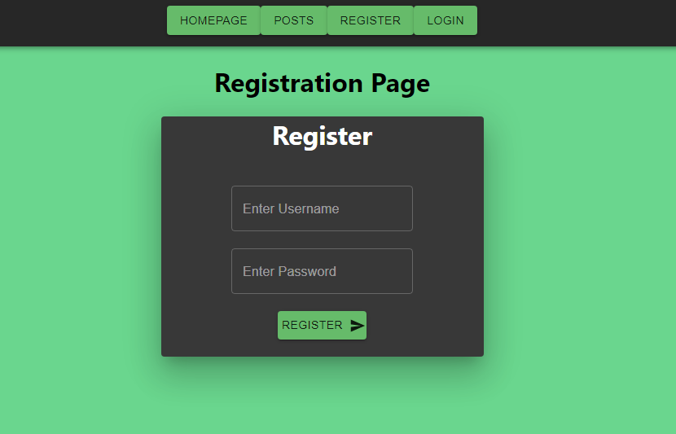

Here you can enter your username in the “Enter Username” field and password into the “Enter Password” field. Once you have entered username and password, press the “Register button” below the input fields to register your account. You cannot register two accounts with the same username.

Once you have registered, you can head to the login page by clicking “LOGIN” button in the navigation bar at the top. The Login page will look like this:

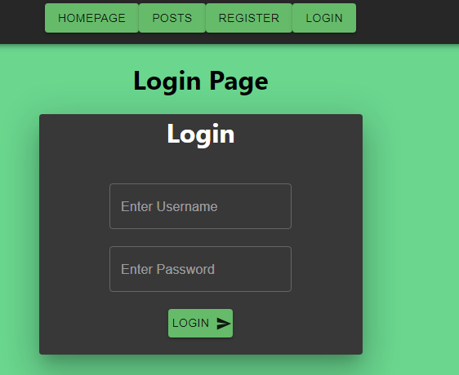

Here you can enter your login credentials that you just created on the register page. Enter your username and your password. Once you have entered the right login credentials, “You are logged in!” text will pop up above the “Login page” text. The page will look like this after successful login:

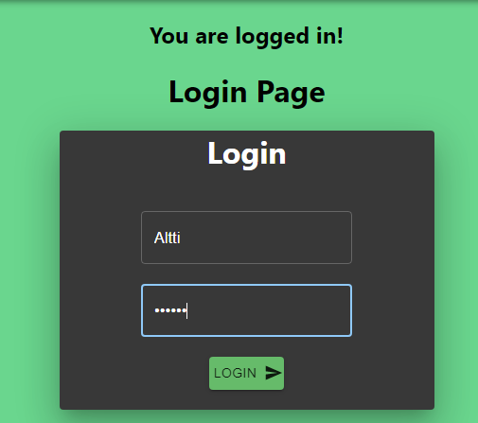

Now that you have logged in, you can head to the posts page to post your code snippets. The page will look about like this when you’re logged in:

On the posts page, you can write your code snippet on the “Write your code snippet” input field, once you have written your snippet, click post button below it to post it. You can comment posts by clicking “Comments” on the left bottom corner of each post. Clicking the “Comments” button will open modulo that will look like this:

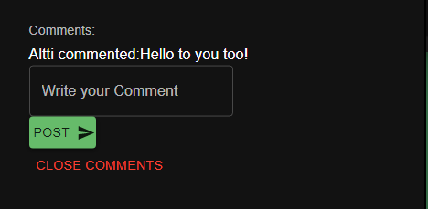

Here you can write your comment and click “Post” button to post your comment. Press the red “Close comments” button to close the modulo. You can also close the modulo by pressing “esc” button on keyboard OR click somewhere else than the modulo. To see all the posts and comments, refresh the page.

You can see posts and comments when you’re not logged in and it will look like this when not logged in:

You can see the comments by clicking the “Comments” button:

NOTE: The application will log you out if you refresh the page, so you have to log in again to post or comment. Navigate through the app with the navigation bar at the top.